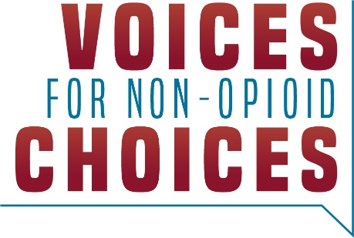

February 13, 2023

The Honorable Chiquita Brooks-LaSure
Administrator
Centers for Medicare and Medicaid Services
U.S. Department of Health and Human Services
P.O. Box 8013
Baltimore, MD 21244

RE: CMS–4201–P Medicare Program; Contract Year 2024 Policy and Technical Changes to the Medicare Advantage and Medicare Prescription Drug Benefit Programs Proposed Rule

Dear Administrator Brooks-LaSure,

On behalf of the patients, providers, families, and health professionals our XX organizations represent, we thank you for the opportunity to comment on the proposed rule and urge you to facilitate widespread availability of non-opioid therapies for patients with coverage under Medicare Part D. We urge the Centers for Medicare and Medicaid Services (CMS) to encourage innovation of and expand access to non-opioids for Part D beneficiaries by propagating guidance to ensure that Part D sponsors offer unfettered access to non-opioids for acute pain management.

Our country’s seniors are not immune to the worsening opioid epidemic. The number of Americans aged 65 and older who died as the result of a natural or semisynthetic opioid overdose increased 63% between 2012 and 2020.¹ In 2021, 1.1 million Medicare beneficiaries were diagnosed with an opioid use disorder, and 50,400 Part D beneficiaries experienced an opioid overdose-from prescription opioids, illicit opioids, or both.² Unfortunately, the Medicare program may unknowingly be making this problem worse.

The majority of Medicare beneficiaries are prescribed opioids to manage post-surgical pain, whether they need them or not. These prescriptions are not just risky for patients, but those around them as well. The vast majority of patients report having leftover opioids following surgery and nearly all — 90 percent — did not properly dispose of them, making them available for abuse, misuse or diversion.³

In recognition of these worsening conditions, the U.S. Department of Health and Human Services (HHS) Pain Management Best Practices Inter-Agency Task Force and the Centers for Disease Control and Prevention (CDC) have updated best practice guidelines for opioid prescribing, urging providers to ensure that non-opioids are the first line of defense for acute pain.^{4, 5} Allowing patients to utilize non-addictive, non-narcotic medications for acute pain management will help reduce the number of opioid prescriptions dispensed, reduce the number of prescription opioid pills available for diversion in communities, reduce the number of individuals misusing opioids, and ultimately help reduce the number of opioid-related drug overdoses.

However, prescribers often don’t have control over the medicines they can offer patients, deterred by aggressive utilization management tactics including prior authorization, step therapy and fail first policies. Because prescription opioids are relatively cheap to manufacture, we are concerned that Part D sponsors may make non-opioids less accessible for beneficiaries by implementing short-sighted utilization management practices, including enhanced prior authorization requirements, imposing additional cost sharing requirements on patients, or placing innovative branded therapies on higher or specialty tiers. These practices are designed to help plans control short-term spending, however, these short-sighted approaches fail to consider the larger picture of the opioid epidemic, which is estimated to cost U.S. taxpayers $1.5 trillion every year.

With several new opioid alternatives in the pipeline and others currently on the market, it is essential we encourage robust access to these therapies for Part D beneficiaries beginning in 2024 and beyond. We encourage the Centers for Medicare and Medicaid Services (CMS) to take further steps to encourage innovation of and expand access to non-opioids for Part D beneficiaries by propagating guidance to ensure that Part D sponsors offer unfettered access to non-opioids for acute pain management.

Thank you for your time and attention to this important issue. We look forward to working with you.

Sincerely,

